**Moderate to Severe Evaluation**

Sample_id : **UNH9EC(Dog)**

Link:<https://release.animalbiome.com/pet/assessment/report/appendix/f45e4f1c-8248-4335-8b79-98370f3109df>

Cats and dogs:

Any two of the following:

(

High Red Flag Megamonas OR (failed)

High Red Flag Sutterella OR (failed)

High Red Flag Collinsella OR (failed)

Low Red Flag Bacteroides OR (**passed)**

Low Red Flag Blautia (**passed**)

);

OR

Dogs:

8 or more yellow flags (**passed**)

OR 8 or more red flags (**passed**)

High red megamonas,suttrella and collinsella failed.

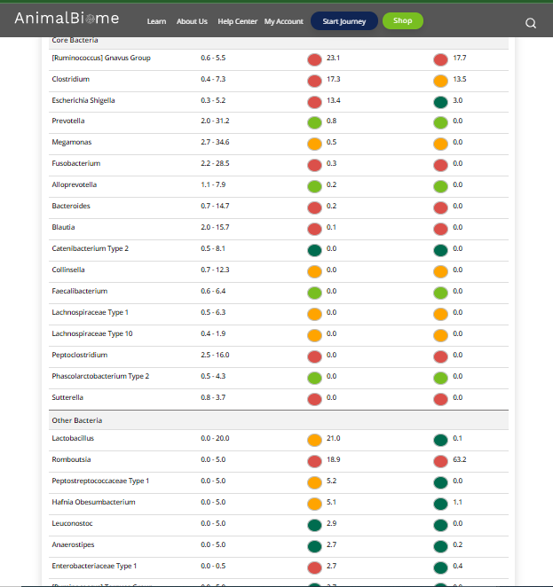

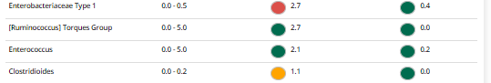

low red blautia : **passed.**

Low red bacteroides : **passed** ( two conditions satisfied ) in the primary group.

Total yellow flags : 8

Red flags : 10

The result : **True True True**

Moderate to severe results:Pass

Expected result : **Moderate to severe**

Achieved result : **passed.**

